

**Project X – API testing using Postman**

**Prepared by: Team BAMP**

**Sophie A. Bohol**

**Cloe Den Mabanding**

**Maureen Portillo**

**Jhomarie Avenido**

User Creation - Basic Role Testing

Creating Users with Different Roles

**Successfully tested creation of users with different roles:**

1. **Student User - Response: 201 Created**

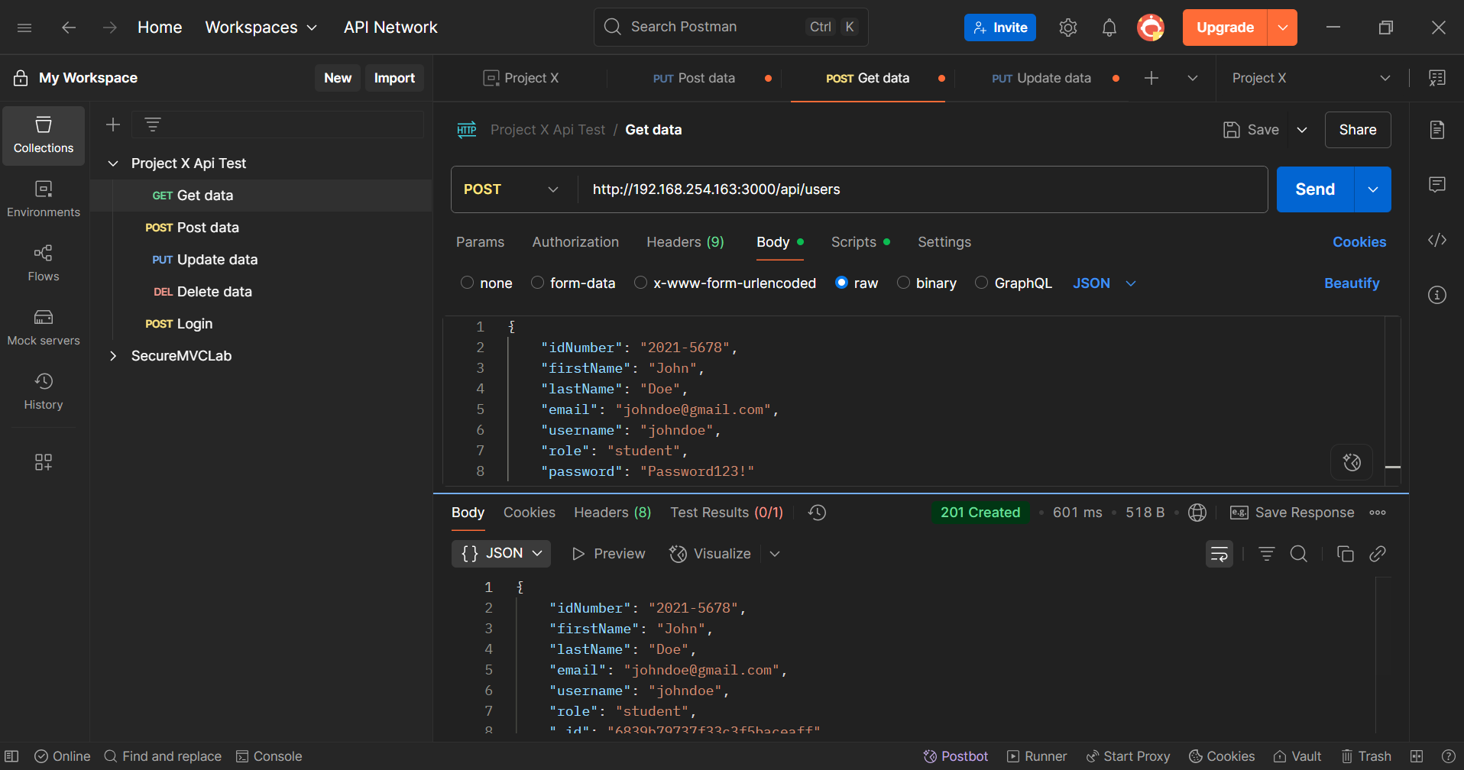

1. Admin User - Response: 201 Created

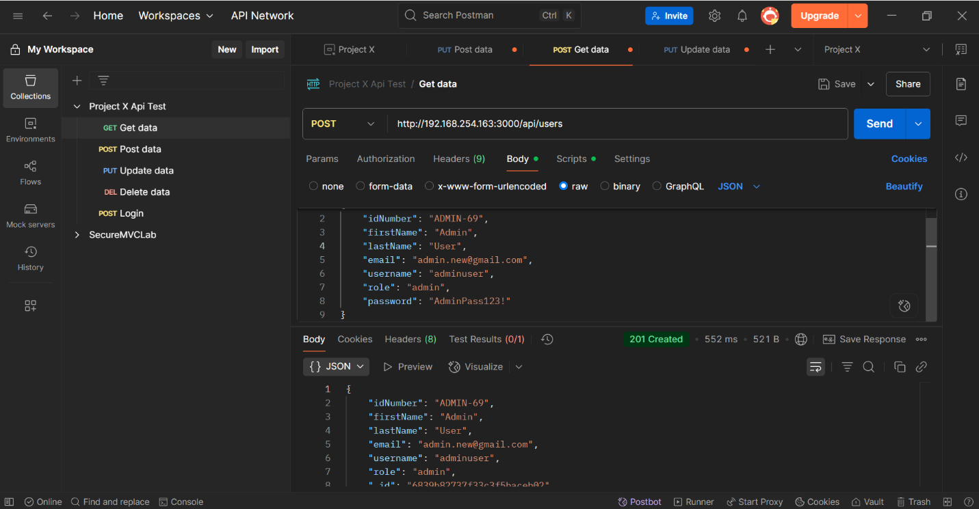

1. 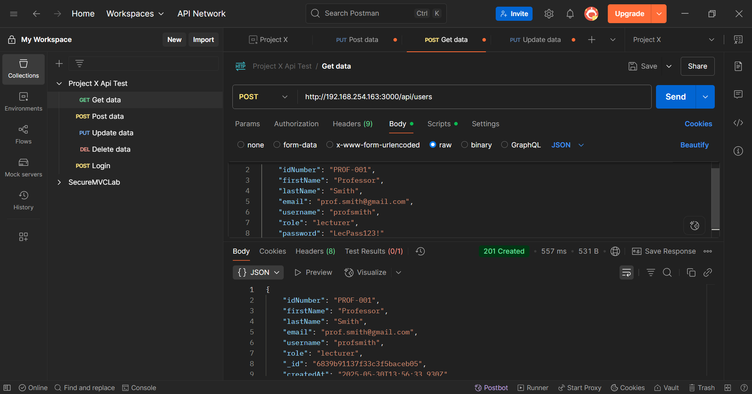**Lecturer User - Response: 201 Created**

**Validation Testing**

1. 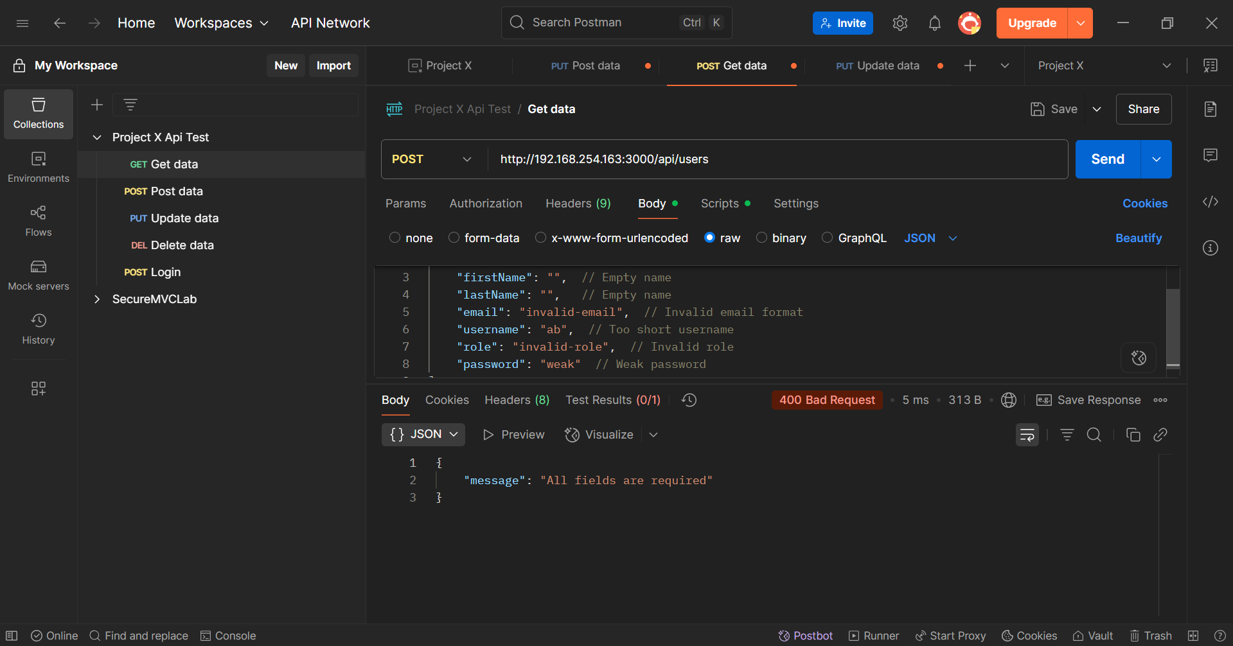**Invalid Data Test**

**Response: 400 Bad Request**

**Error: "All fields are required”**

1. 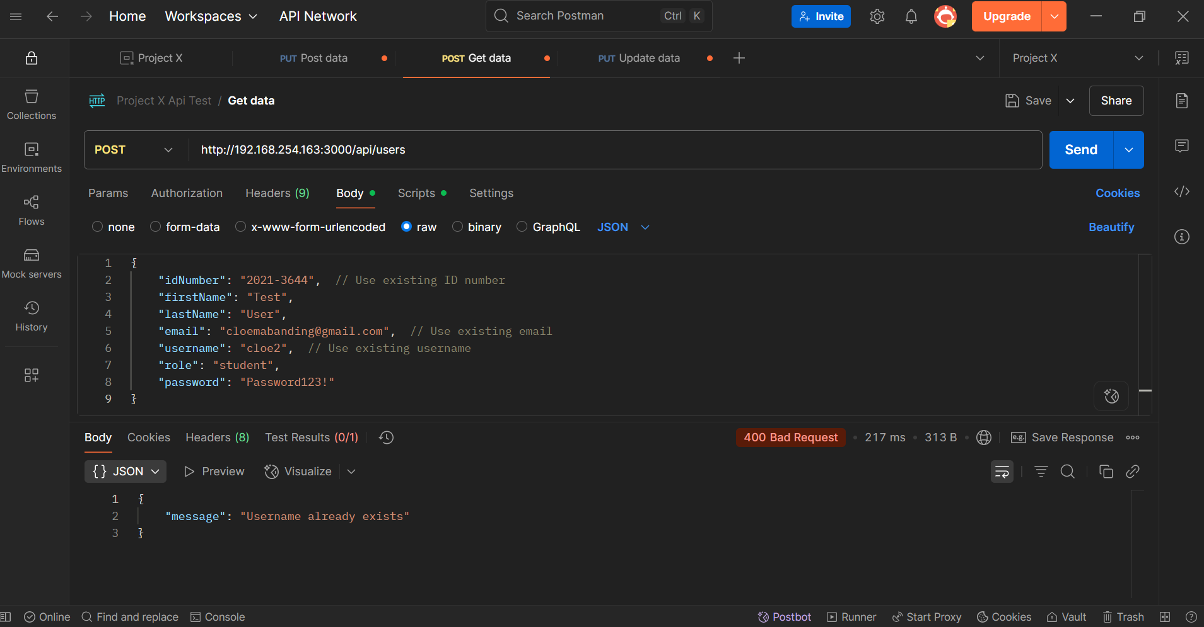**Duplicate Values Test**

**Response: 400 Bad Request**

**Error: "Username already exists"**

1. 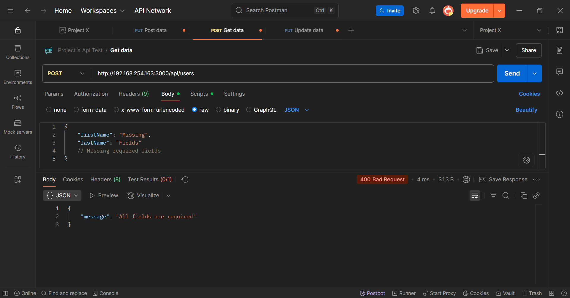**Missing Required Fields Test**

**Response: 400 Bad Request**

**Error: "All fields are required"**

1. 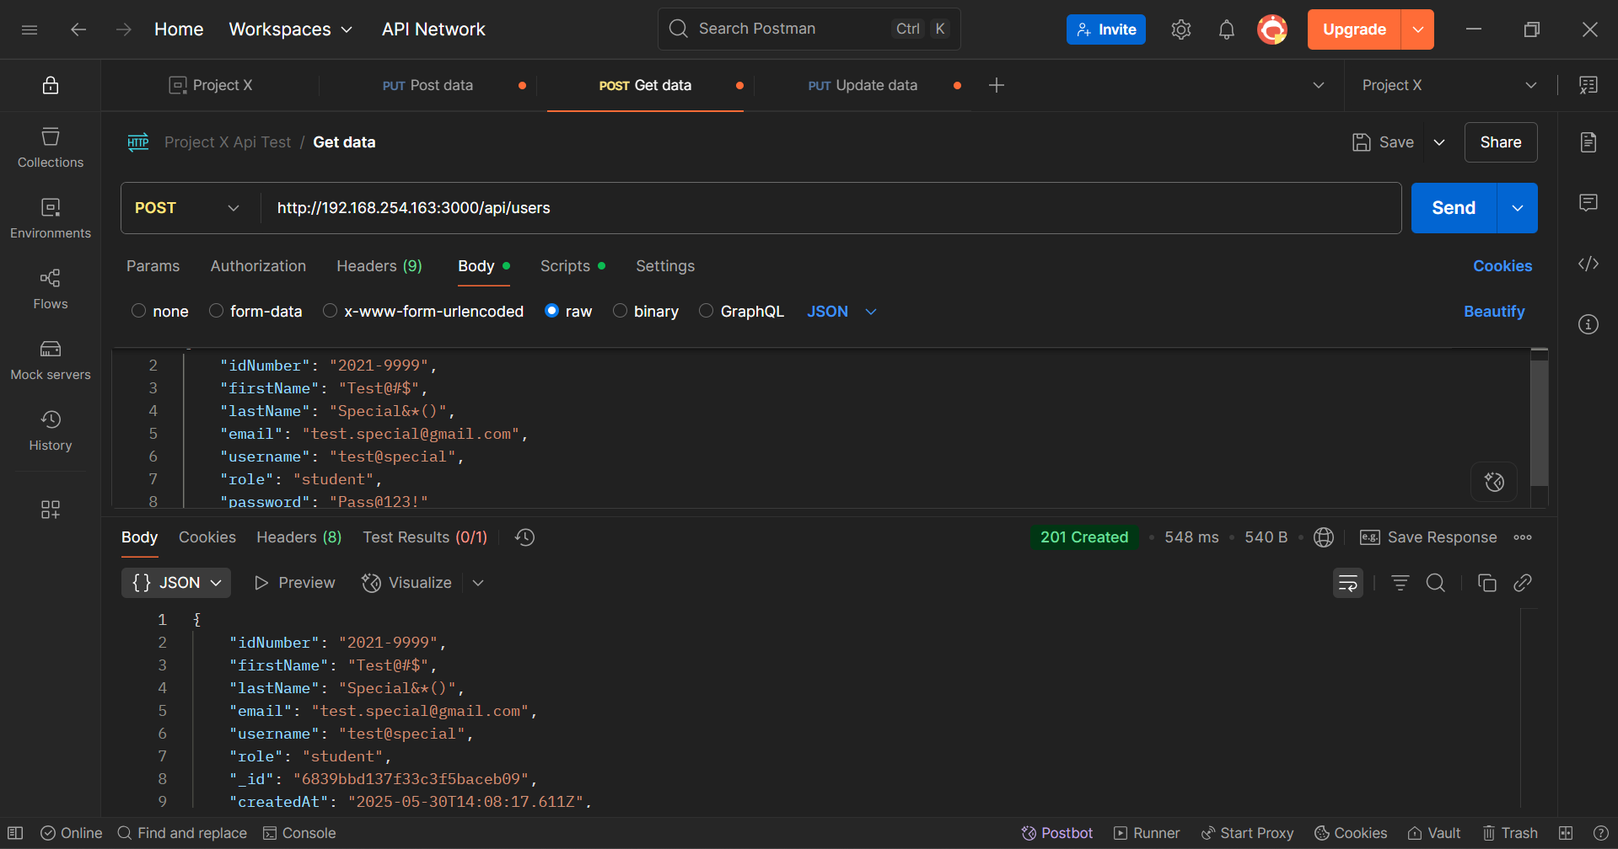**Special Characters Test**

**Response: 201 Created**

**Note: System successfully handles special characters in name fields**

**User Creation API Testing Summary**

**Endpoint: POST http://192.168.254.163:3000/api/users**

**Successfully Tested:**

- Creation of all user roles (student, admin, lecturer)

- Input validation for required fields

- Email format validation

- Username uniqueness validation

- Password strength requirements

- Special character handling

- Duplicate entry prevention

- Error message consistency

**Validation Rules:**

1. All fields are required

2. Email must be in valid format

3. Username must be unique

4. Password must meet strength requirements

5. Role must be one of: "student", "admin", "lecturer"

6. ID Number format varies by role:

- Student: "2021-XXXX"

- Admin: "ADMIN-XX"

- Lecturer: "PROF-XXX"

**Response Codes:**

- 201: User successfully created

- 400: Invalid data or missing fields

- 409: Duplicate username/email

**Authentication Testing – Login**

**1. Successful Admin Login**

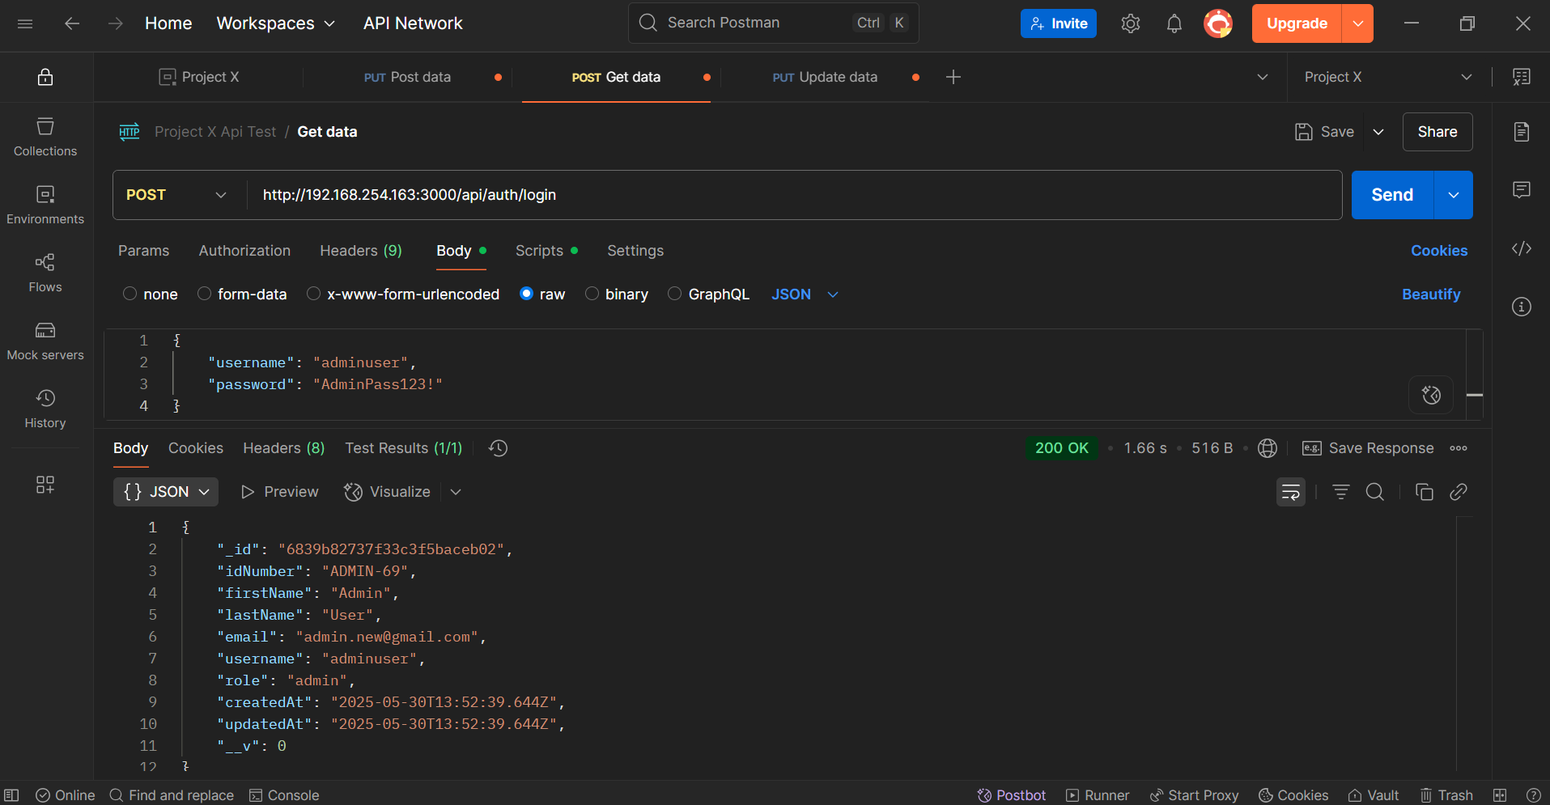

**Response: 200 OK**

**Returns user details with role "admin"**

**2. Test Student Login**

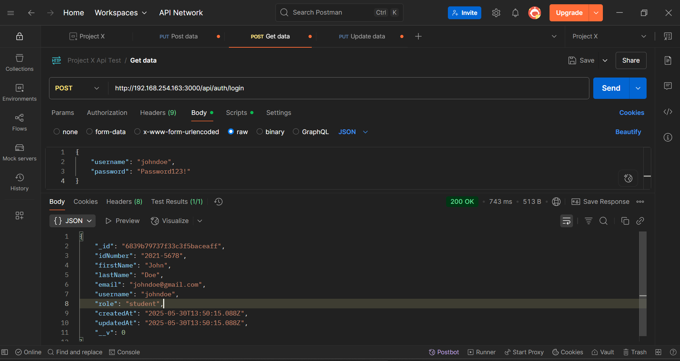

**Response: 200 OK**

**Returns user details with role "student"**

1. **Test Lecturer Login**

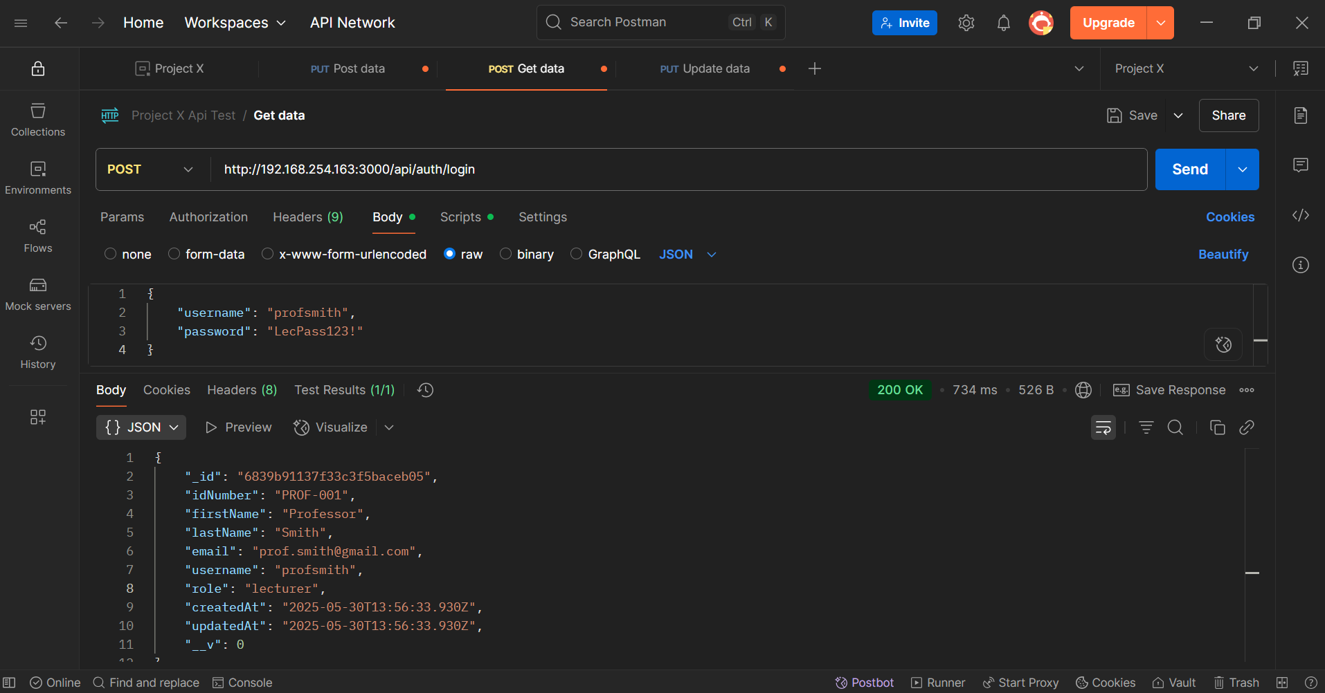

**Response: 200 OK**

**Returns user details with role "lecturer"**

**Test Cases:**

**1. Successful Logins**

**- Admin login**

**- Student login**

**- Lecturer login**

**Response includes:**

**- User ID**

**- ID Number**

**- Full Name**

**- Email**

**- Username**

**- Role**

**- Timestamps**

**Course Testing**

1. **Create Course Testing**

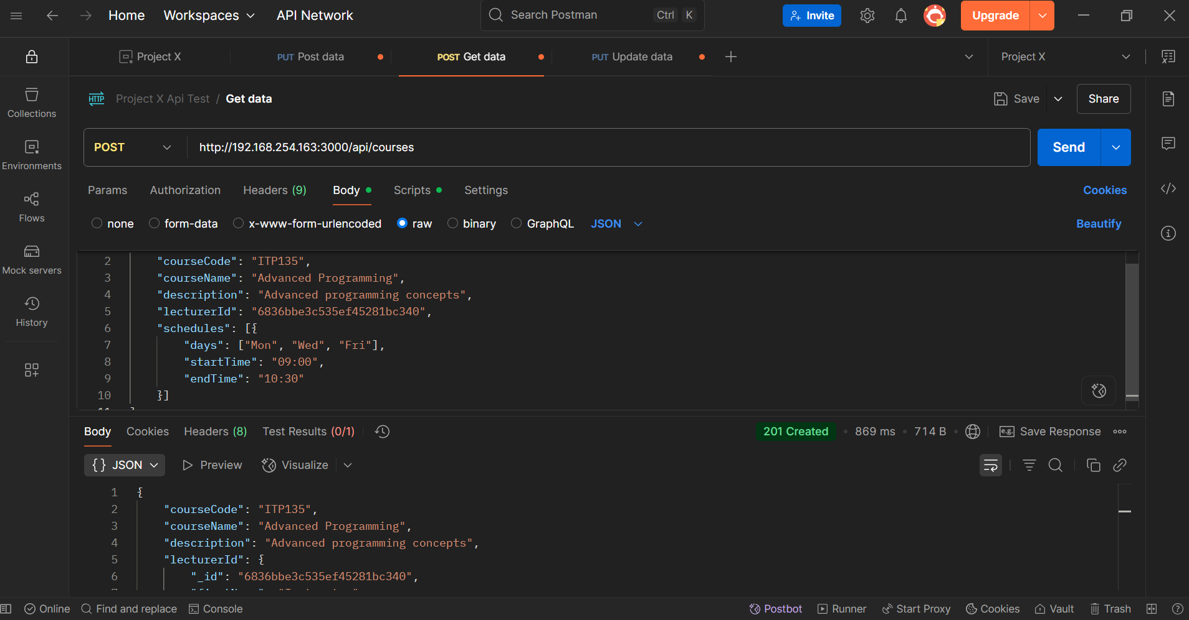

**Test Invalid Course Creation**

1. **Missing Required Fields**

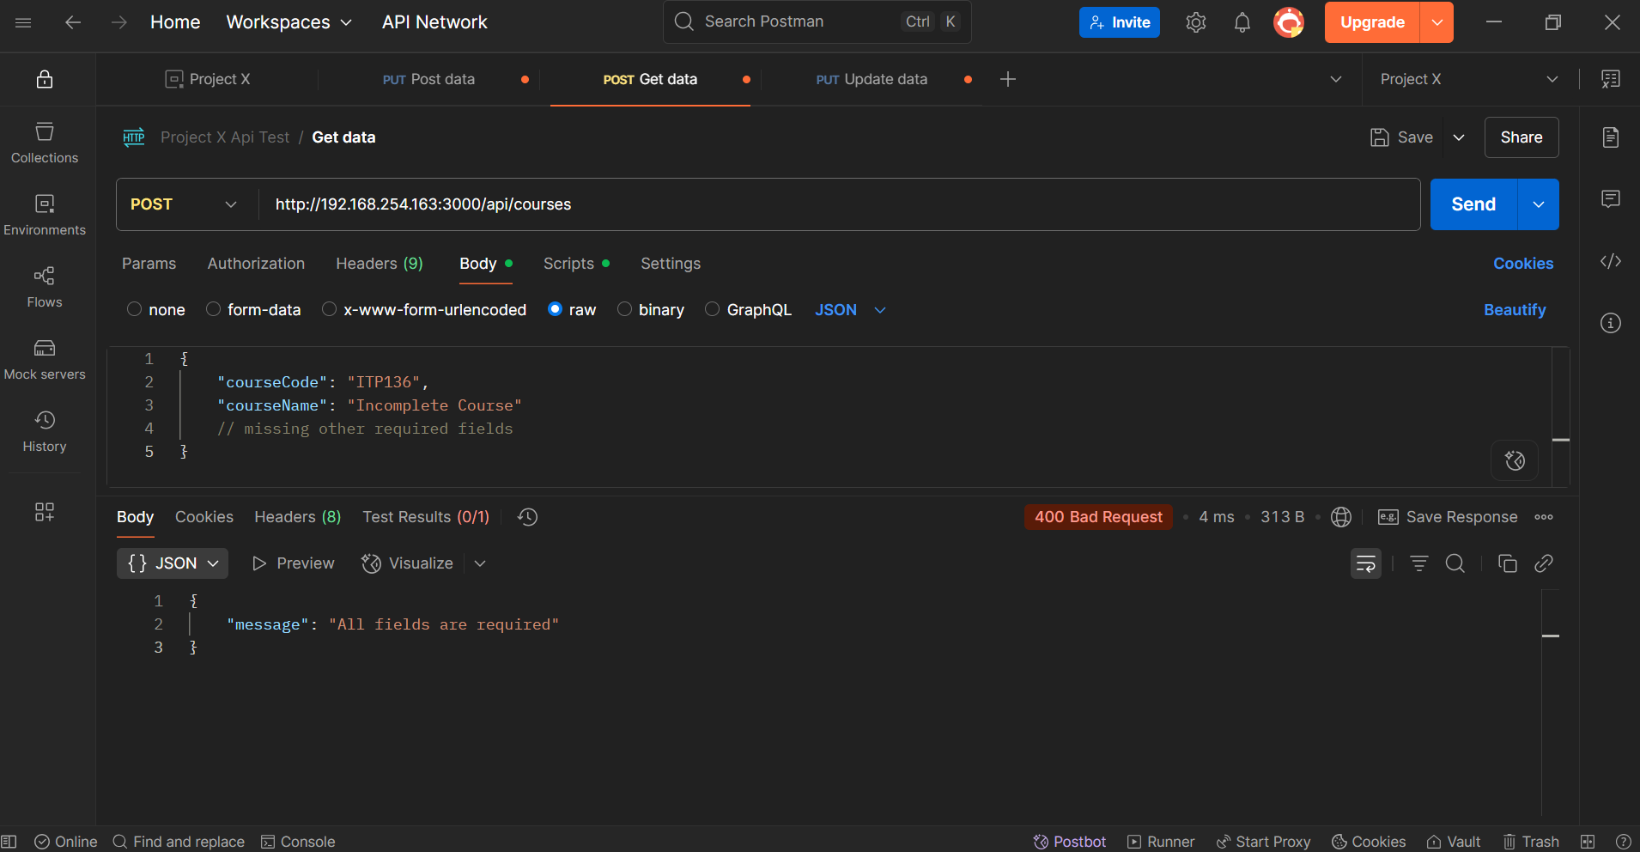

1. 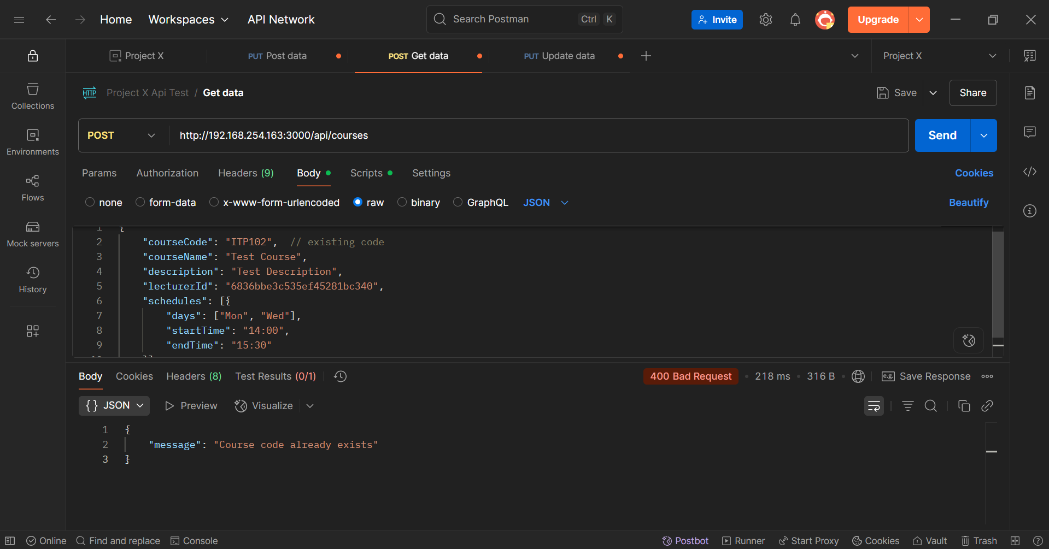**Duplicate Course Code**

**Get Courses (GET)**

1. **Get All Courses**

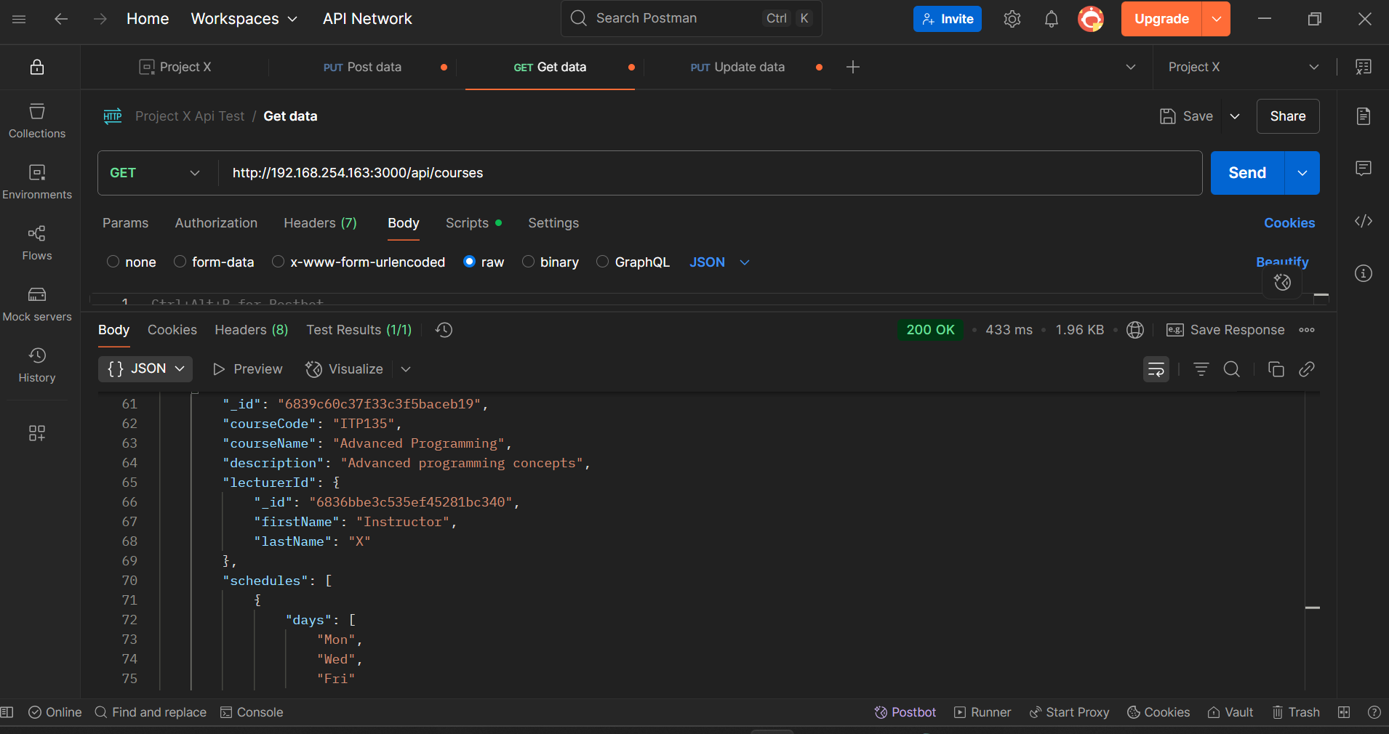

1. 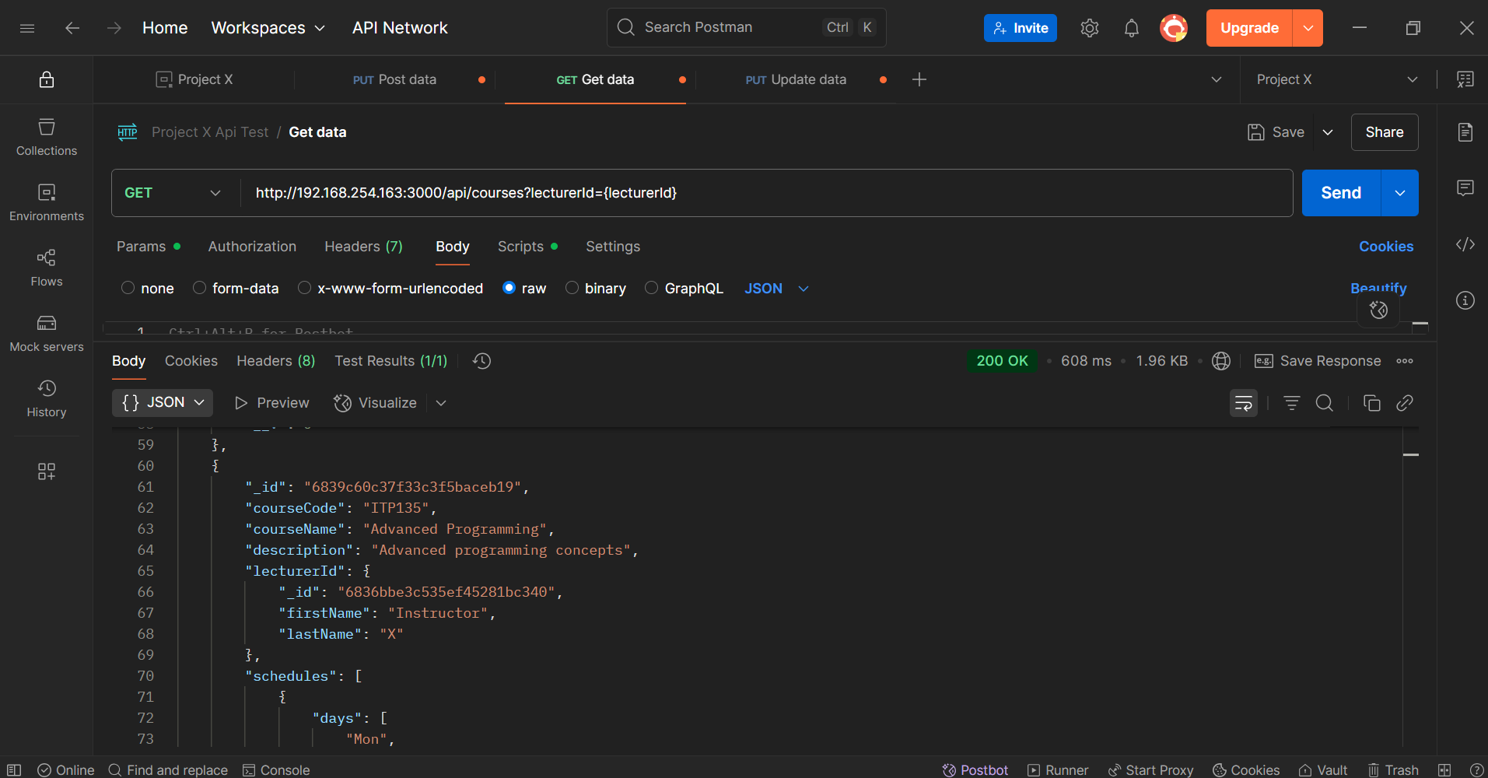**Get Courses by Lecturer**
2. **GET Course by ID**

**Error Responses:**

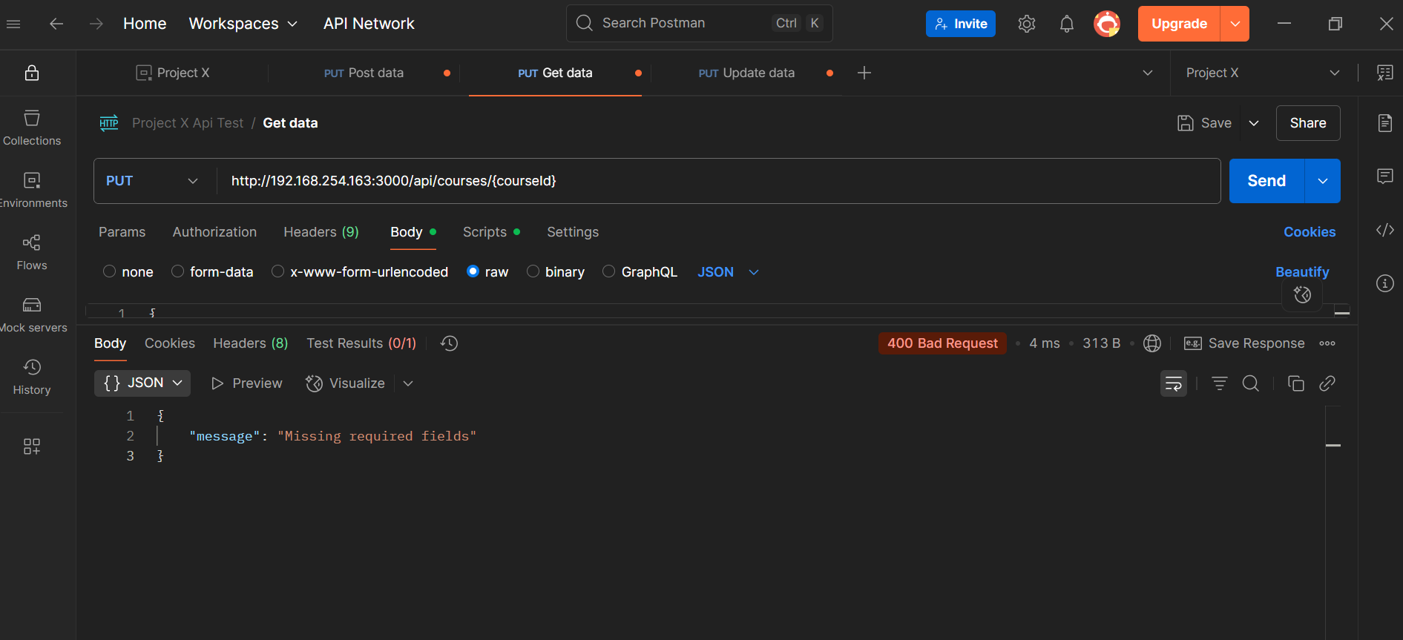

**Occurs when:**

  - Course ID doesn't exist

  - Invalid course ID format

  - Course has been deleted

1. **Update Course (PUT)**

**Error Responses:**



**Occurs when:**

  - Required fields are missing

  - Invalid schedule format

  - Empty request body

**Attendance API Testing**

1. 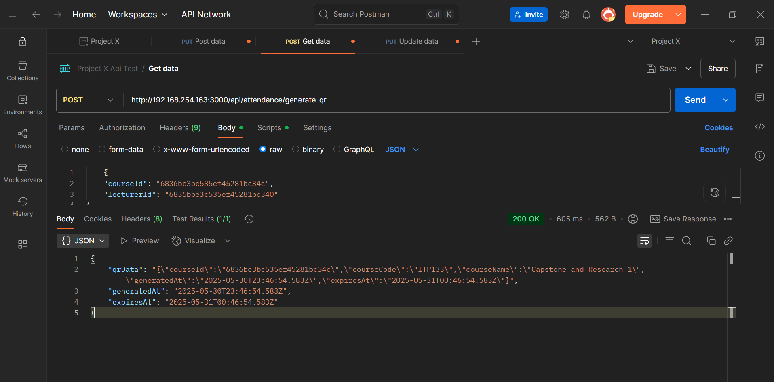**Generate QR Code for Attendance**

**Response: 200 OK**

**Returns: QR code data with generation and expiry timestamps**

**2. Scan QR Code**

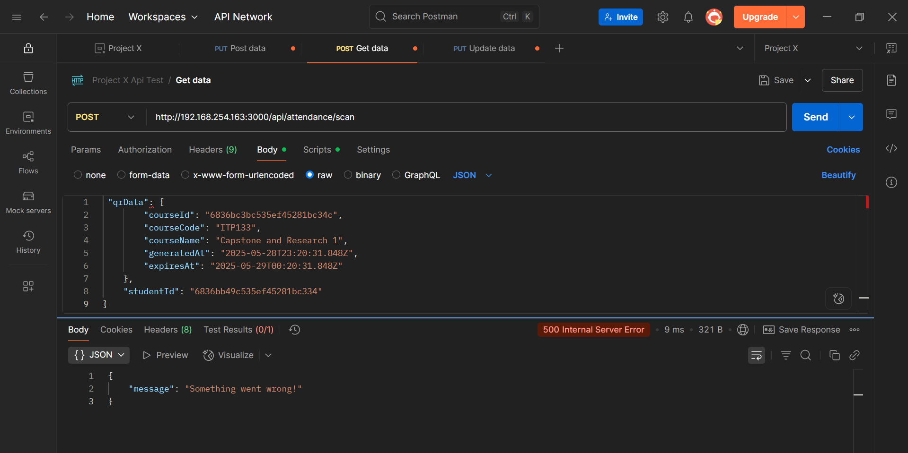**POST /api/attendance/scan**

**Important Notes:**

**- The `qrData` must be passed as a string, exactly as received from generate-qr**

**- The QR code is valid for 1 hour from generation**

**- Each student can only scan once per QR code**

**- Time is based on Philippines timezone (UTC+8**

**GET Attendance Record**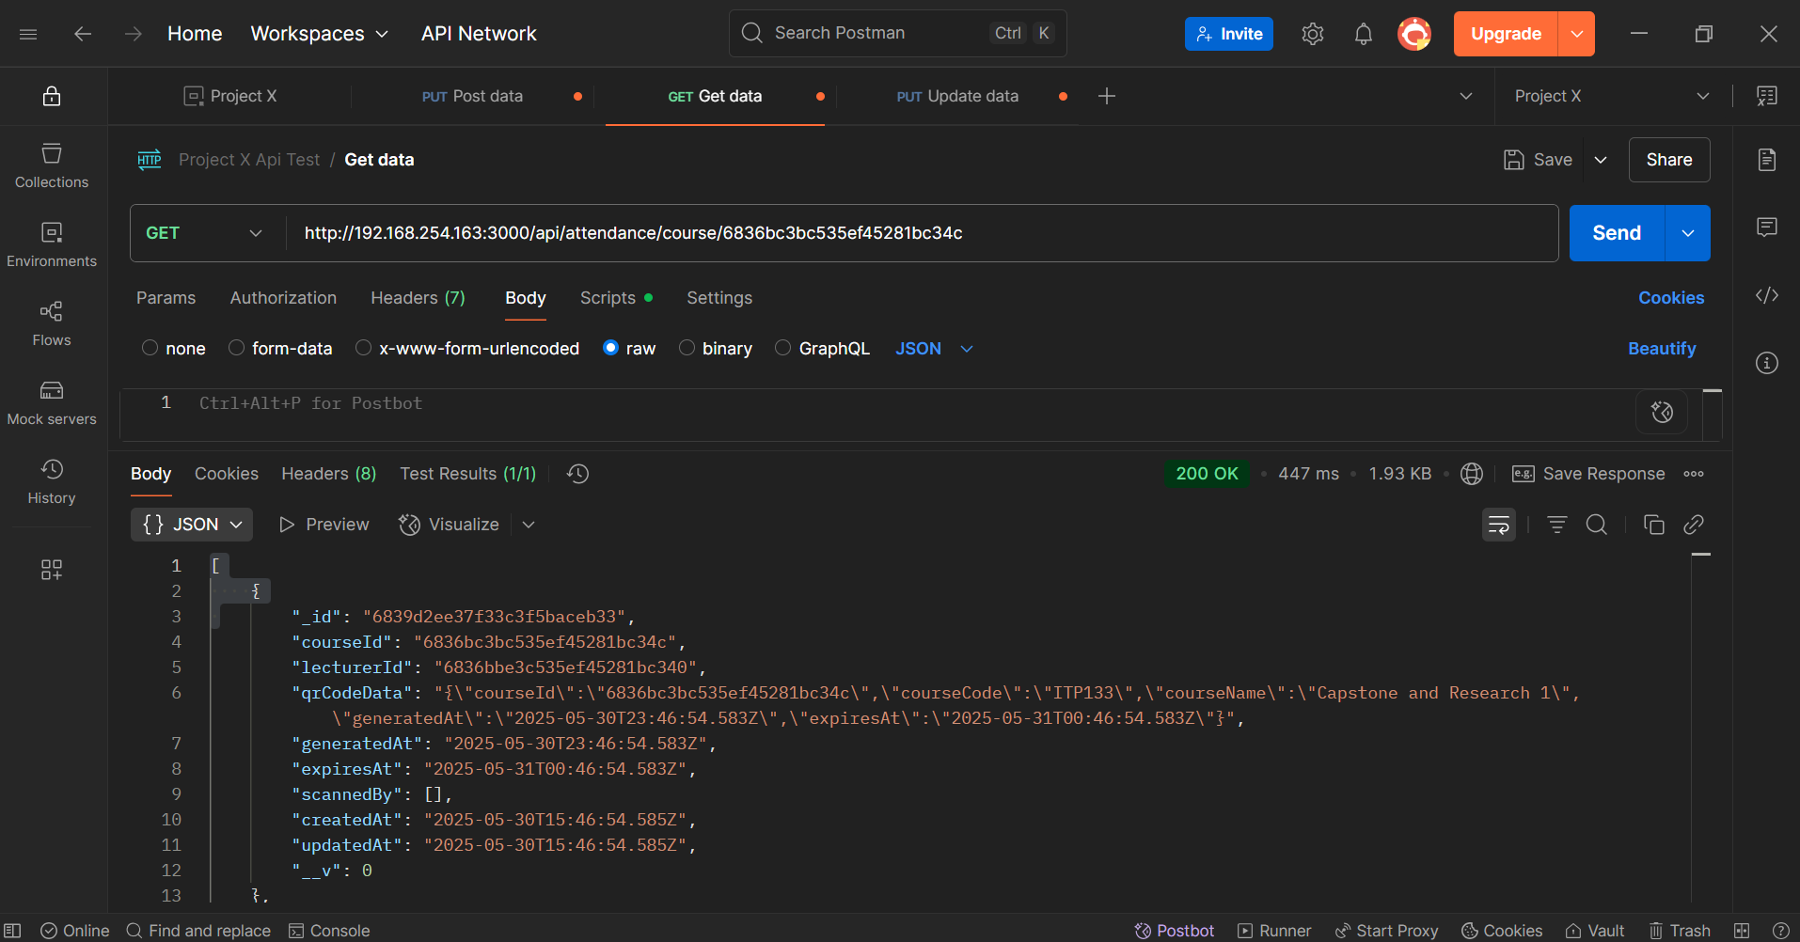

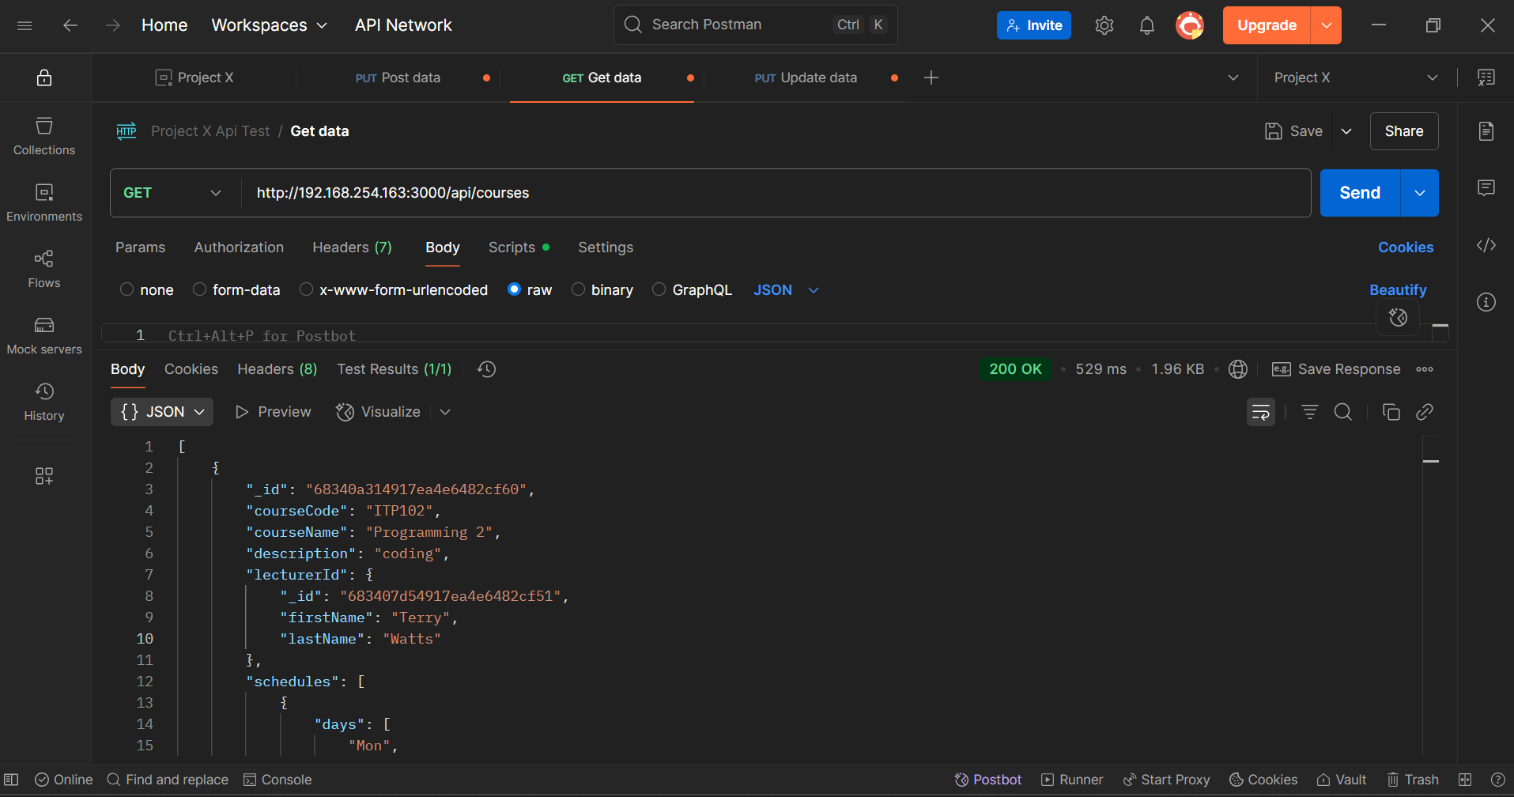**Course Management**  
  
**GET Courses**

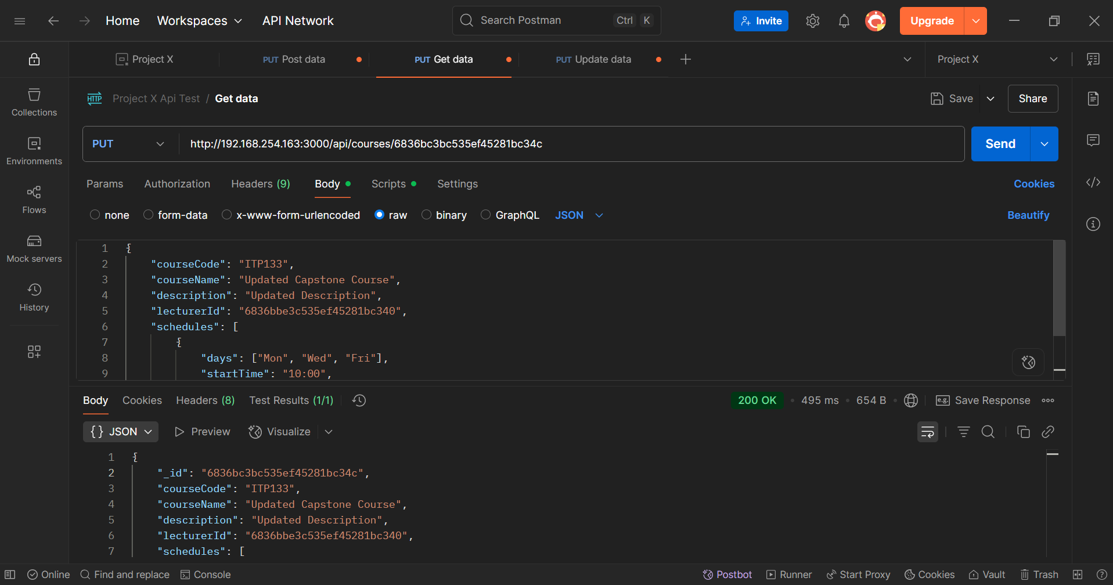**PUT Courses**

**DELETE Course**

**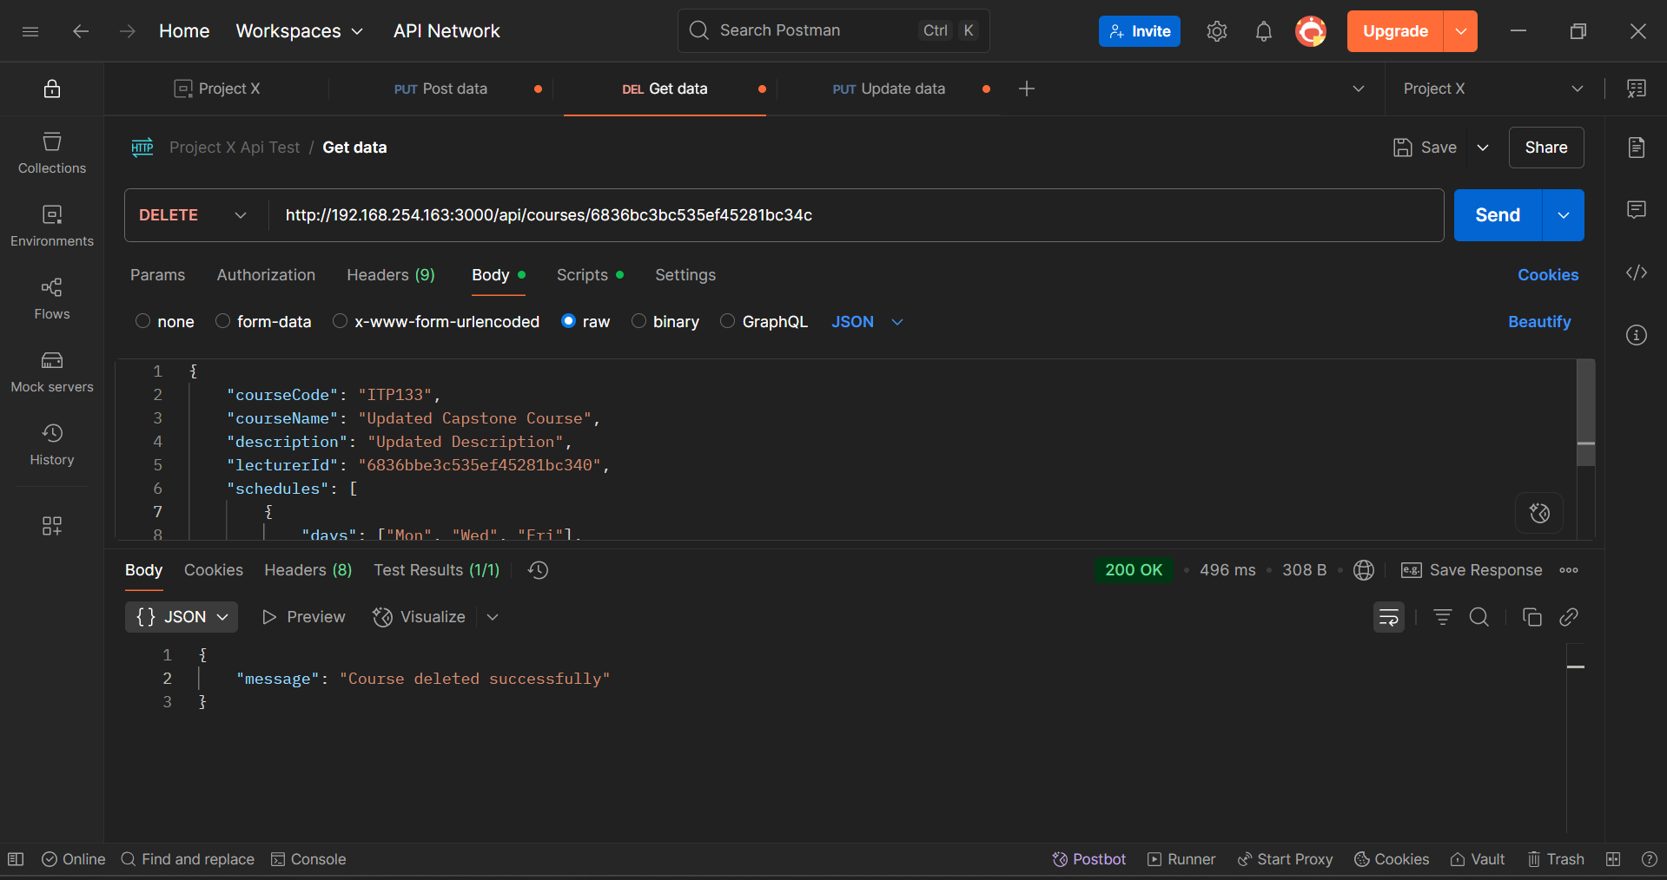  
Test Login Logs**

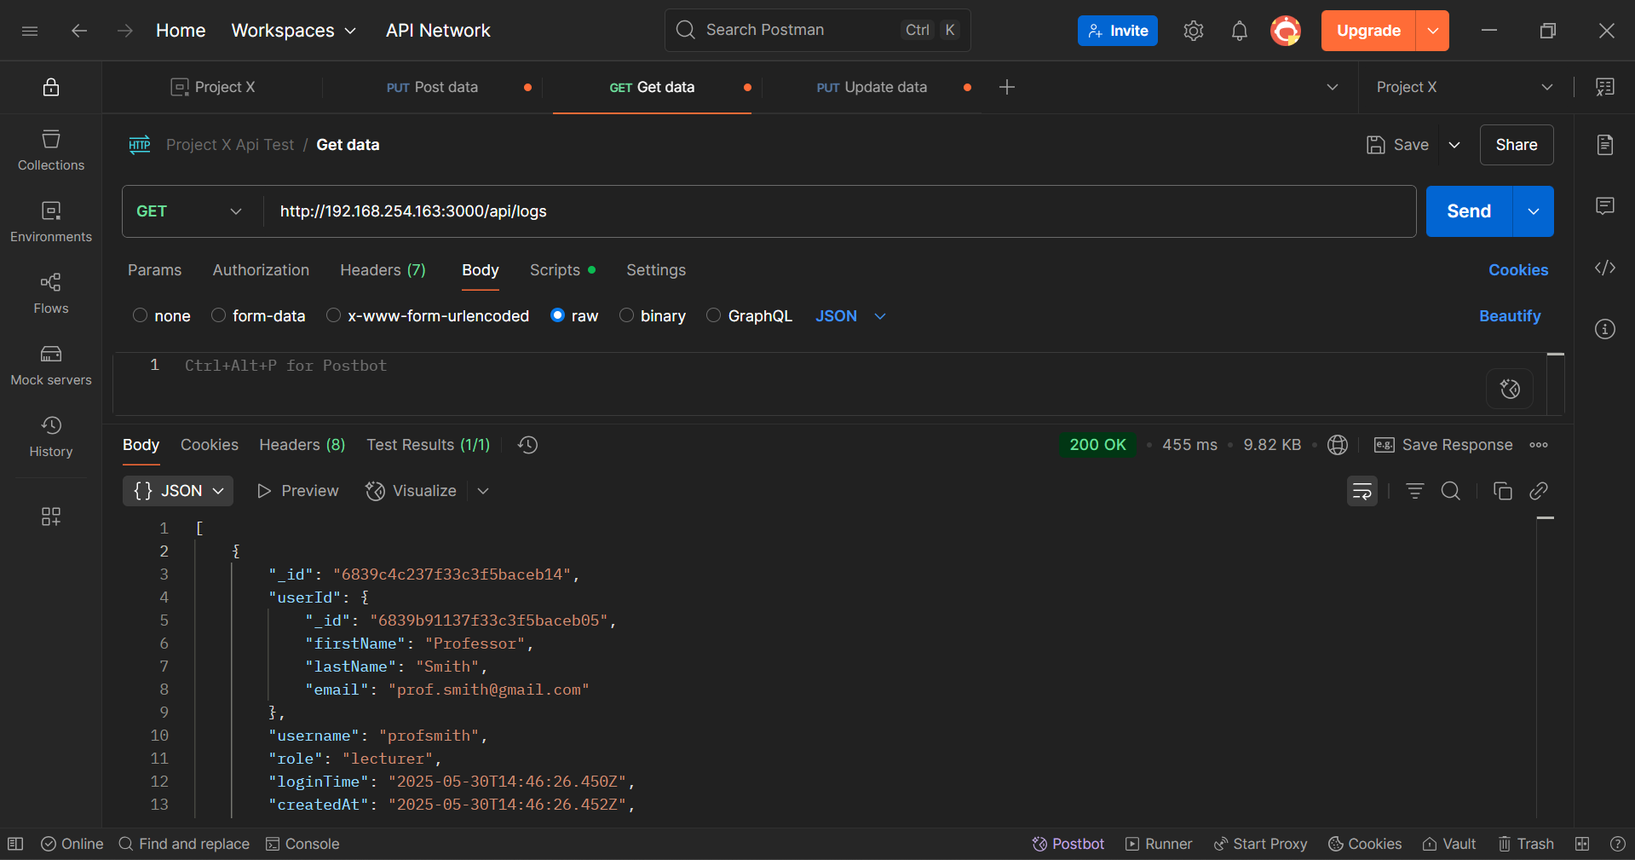

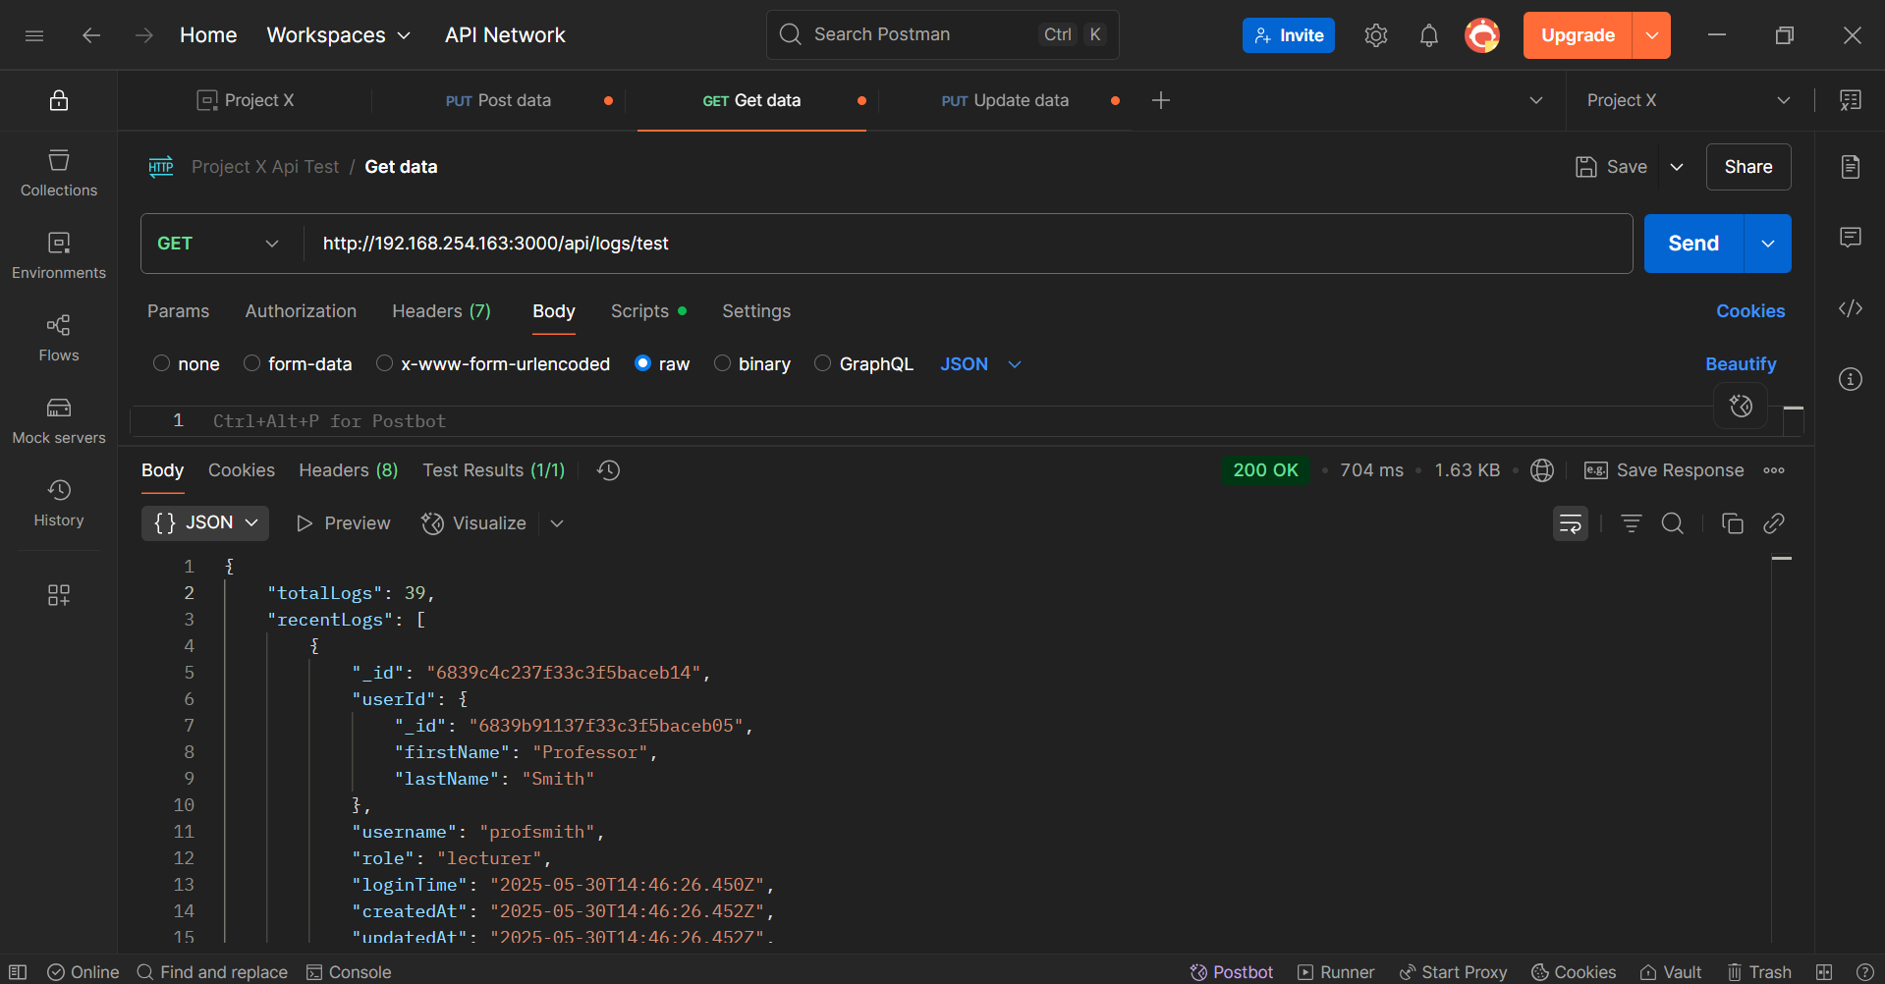

**Validation Testing Results**

All endpoints handle:

- Required fields validation

- Data format validation

- Duplicate entry prevention

- Authorization checks

- Error responses

**Security Features Verified**

Implements:

- User role authorization

- Input validation

- Duplicate prevention

- Session management

- QR code expiration

Performance

All endpoints respond within acceptable time:

- Average response time: < 1 second

- Successful data retrieval and storage

- Proper error handling